DANNY LAKE
SUMMARY CV
TOURING STANDUP COMIC
CONTACT INFORMATION:
C (408) 384 6647
E dannylakecomic@gmail.com
M dannylakemanagementann@gmail.com
W www.dannylakecomic.com
A PO 20698, San Jose, CA 95160
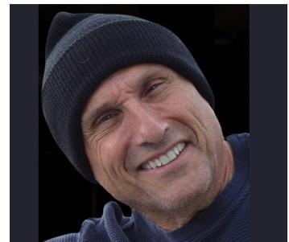

SHORT, SUMMARY CV 2026/2027
Danny is an internationally touring comic who has performed at over 100 comedy venues including a few of his favorites, the Improv, Gaslight Theatre, Rooster T Feathers, and Tommy T’s comedy clubs. From 2024 through 2026, Danny has sold out every venue to standing room only audiences as a headliner. Danny has appeared in one movie and on many podcasts including a New York comedy podcast which attracted about 77,000 viewers—the most ever for this venue.
Danny was chosen for the Funniest of the Fest out of 60 top name comics for the LoudMouth Comedy Festival, San Diego area. Danny has appeared on Roku TV and Amazon Fire TV.
Danny is well known for his tag line “I don’t get it man. I just don’t get it” which is often repeated by the audience as he walks to the stage at the beginning of a standup performance.
PHOTO PORTFOLIO BELOW.



